**Image1 - All Good (All segments Shown -Validation: Pass)**

During –All segment Input GPIO Triggered

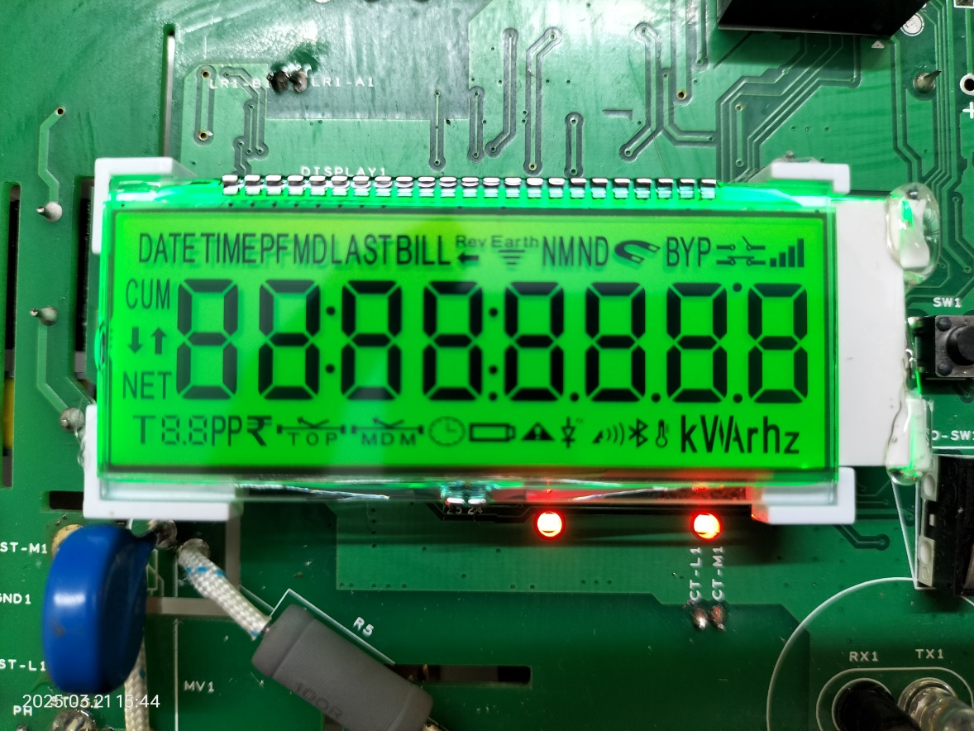

Image2 – Blank (Display Total Blank –Validation: Pass)

During –Blank Input GPIO Triggered

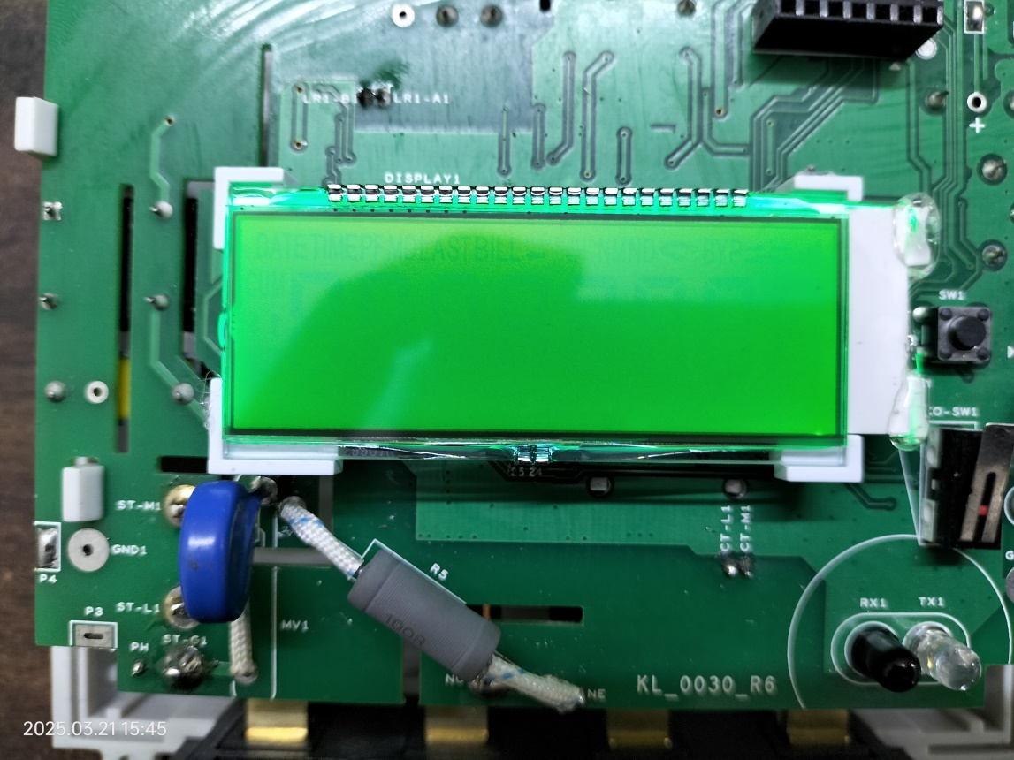

Other some of Failed Condition

Image3 - Digit1 & LAST - Icon missing (Validation: Fail)

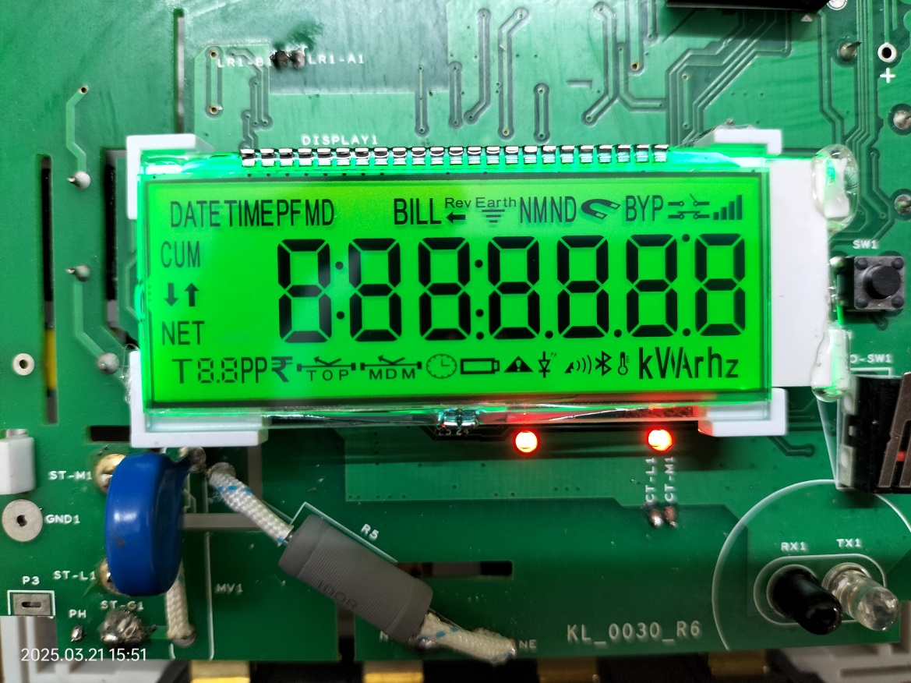

Image4 - Segment f missing in Digit8 & LED1 - OFF

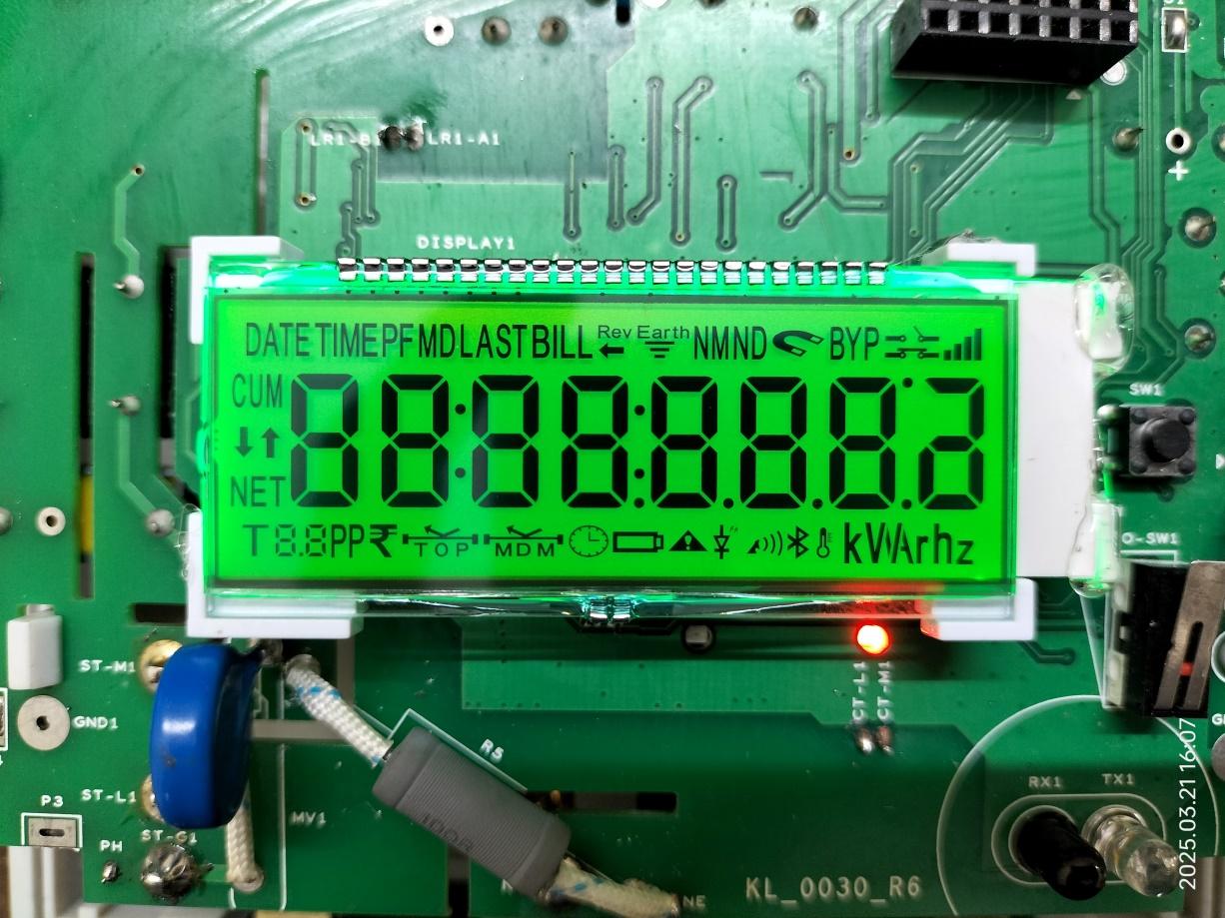

Image5 - DATE - Icon missing (Validation : Fail)

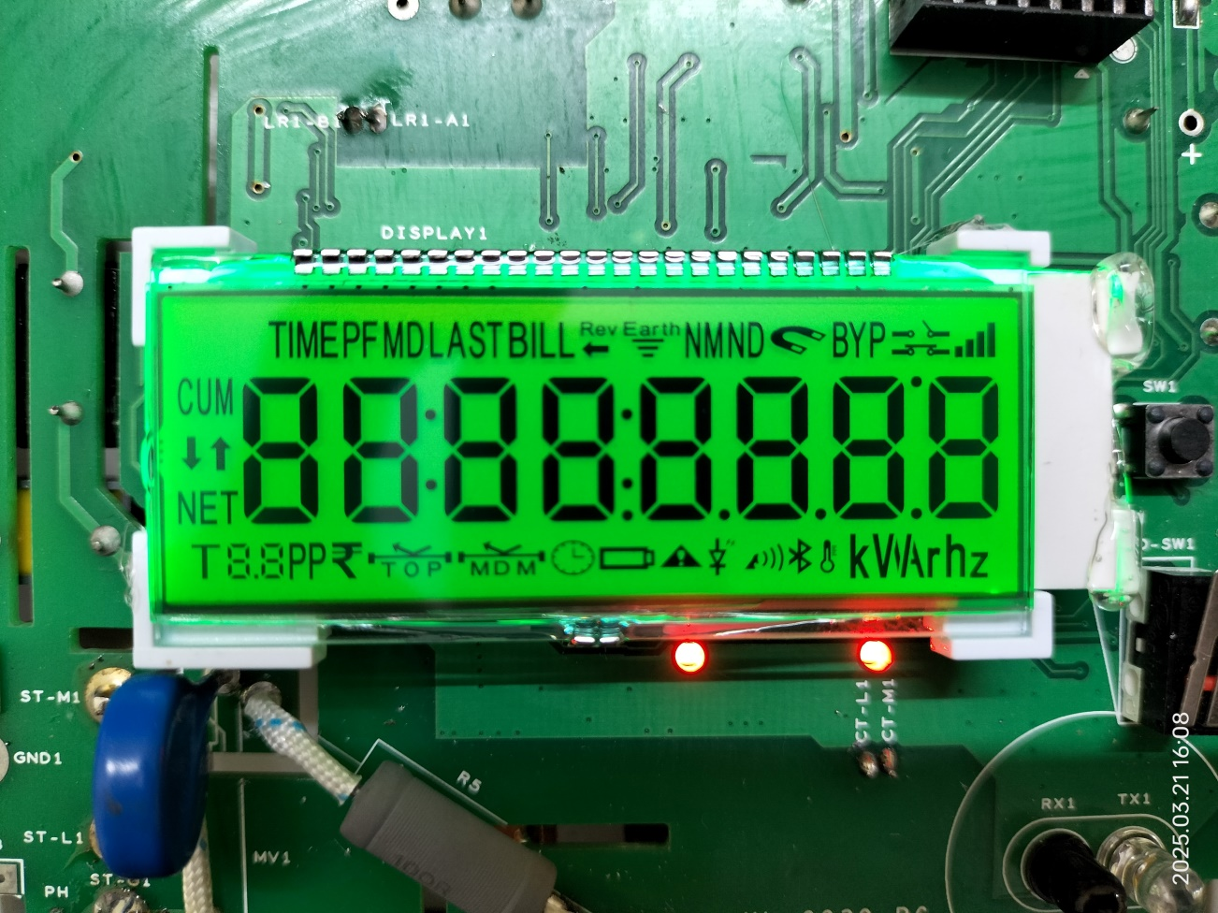

Image6 - BYP - Icon missing & LED1,LED2 – OFF (Validation :Fail)

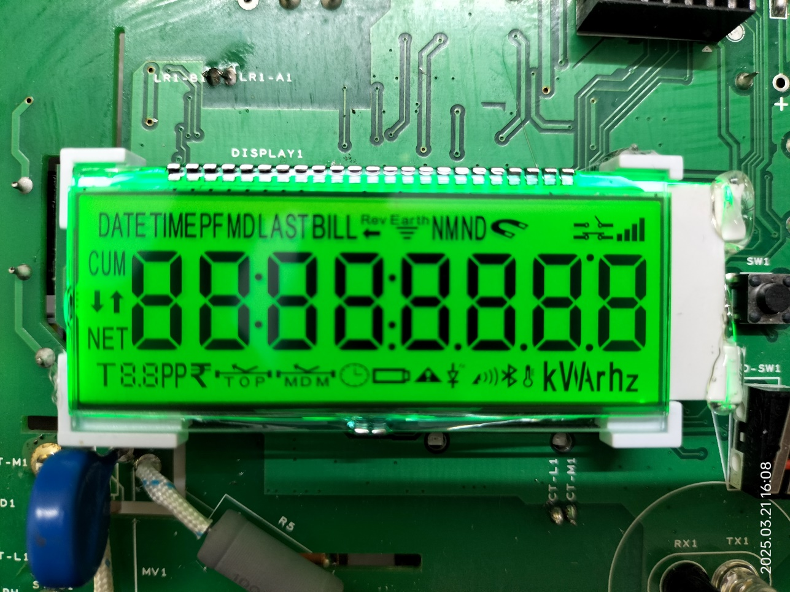

Image7 - Rupee - Icon missing  & LED1,LED2 – OFF(Validation : Fail)

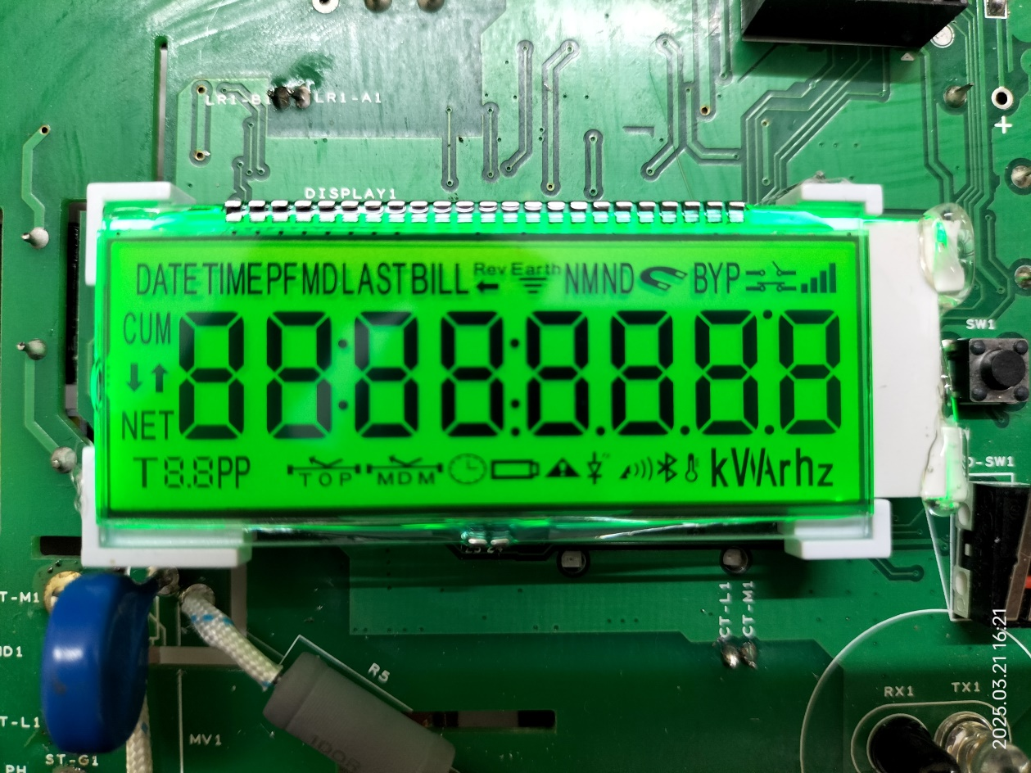

Image8 - Segment-g missing in Digit5  & LED1 – OFF( Validation: Fail)

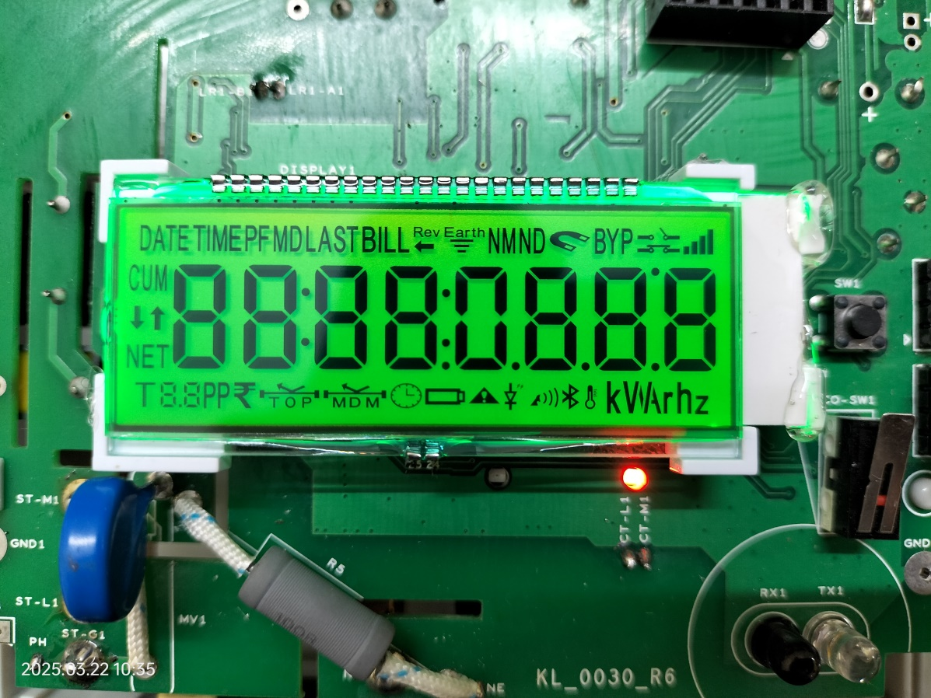

Image9 - Dot1 missing & LED1,LED2 – OFF(Validation :Fail)

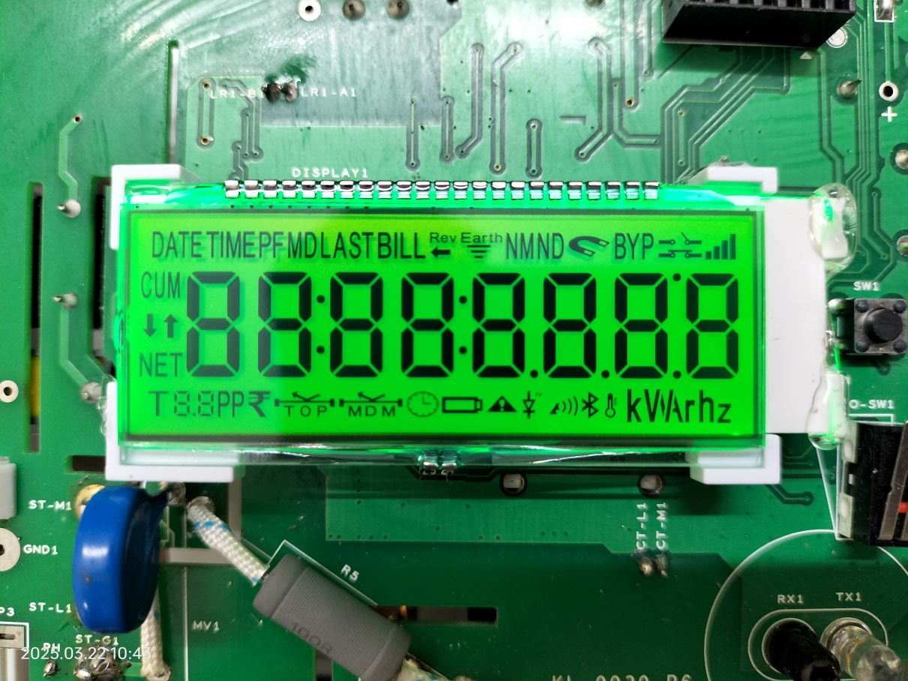

Image10 - Colon & Digit9 missing & LED2 – OFF (Validation: Fail)

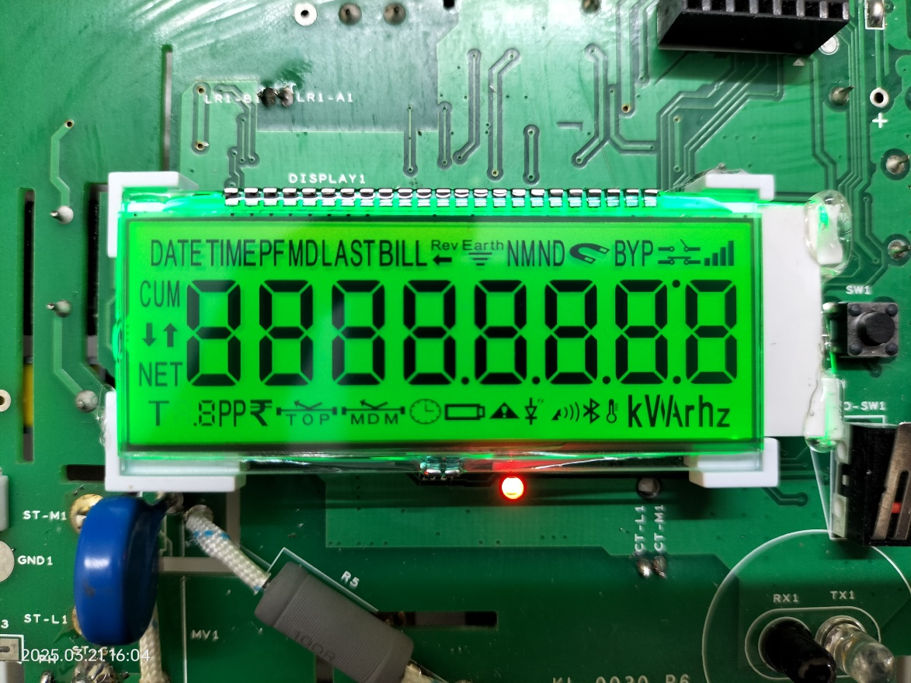

Image11 - Bluetooth - Icon missing (Validation: Fail)

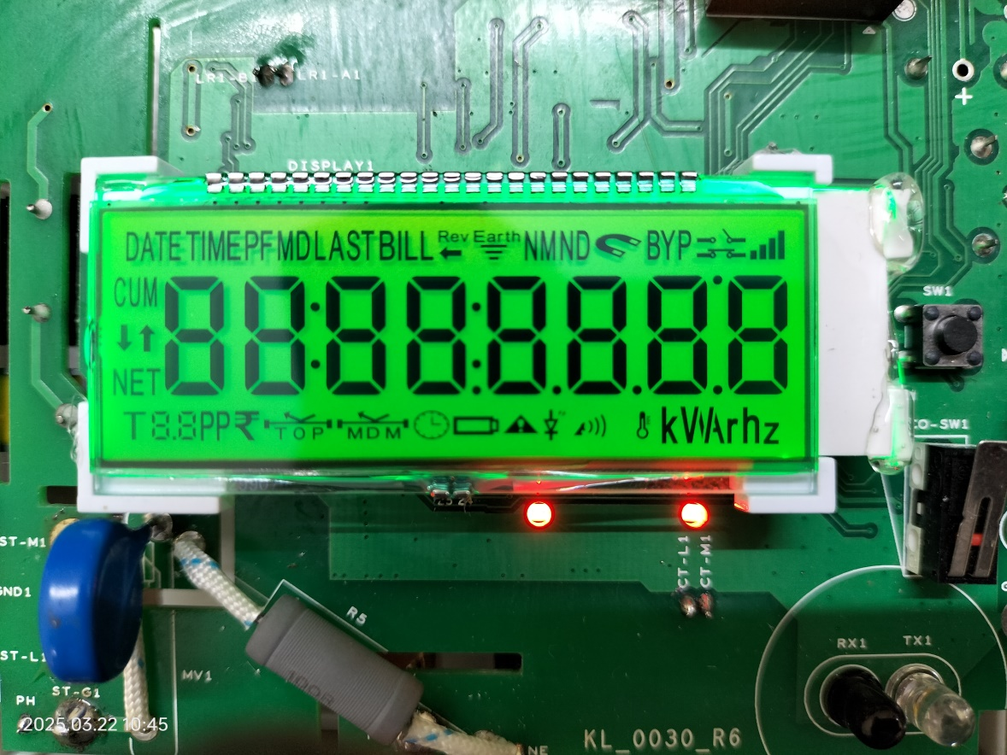

Image12- Signal2 - Icon missing & LED1, LED2 – OFF (Validation: Fail)

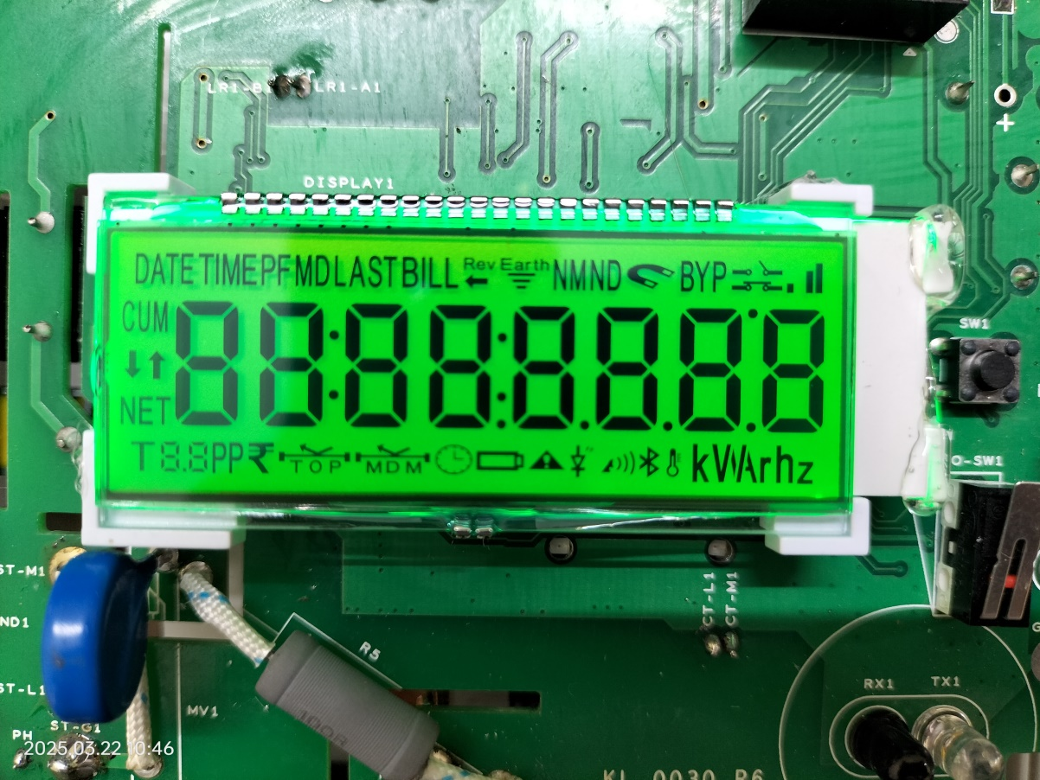

Image13 - W- Icon missing  & LED2 – OFF (Validation: Fail)

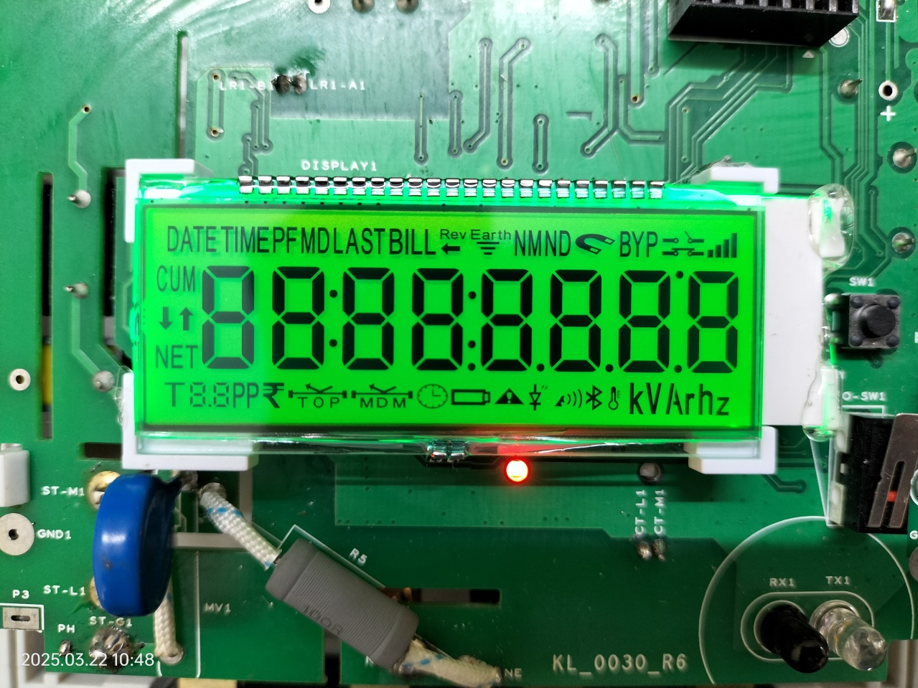

Image14 - Dot6 missing  & LED1 – OFF (validation:Fail)

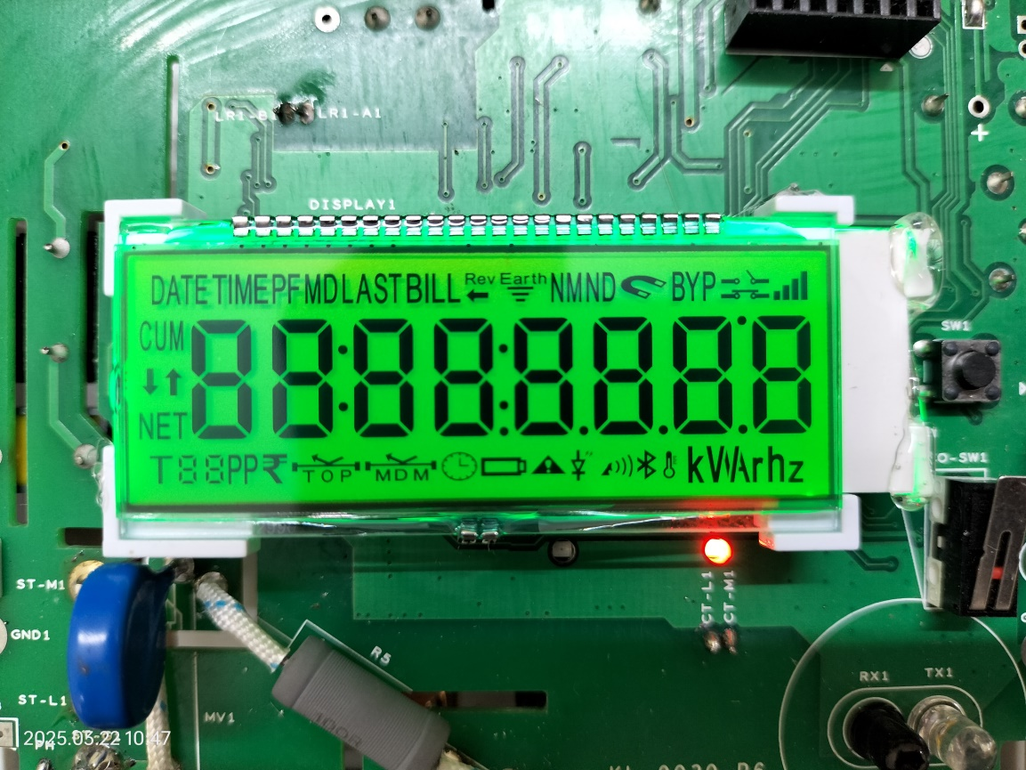

Red Marked Area only Validation Required . Rest of the area no need validate .

